**User:**

I like the minimalist and sleek design style of the energy harvesting device. It should look clean and modern without unnecessary details.

The energy harvesting device is planned to be deployed in a coastal urban environment in Australia. The design needs to take into account the city where it will be applied to ensure consistent energy output throughout the year. Installation must be straightforward. In terms of maintenance, the unit should be designed to minimise the need for frequent repairs and, where necessary, key components should be easily accessible.

The equipment must comply with Australian Standards for Electrical Equipment. The design should be compact to fit into the limited urban space where the installation is specified. Considering the budget of A$50,000, we should prioritise durable materials, balancing cost and longevity.

Based on the above background, I will be designing an energy harvesting device.

The energy harvesting device shall require three key modules:

1. The energy accumulation module functions to derive energy from an external source outside the energy harvesting device.

2. The energy storage module functions to store the accumulated energy inside the energy

harvesting device.

3. The energy utilization module utilizes the harvested energy to power other small devices such as sensors, heating/cooling devices, actuators, and low-power devices.

Please give me as many and reasonable and complete designs as possible.

**GPT:**

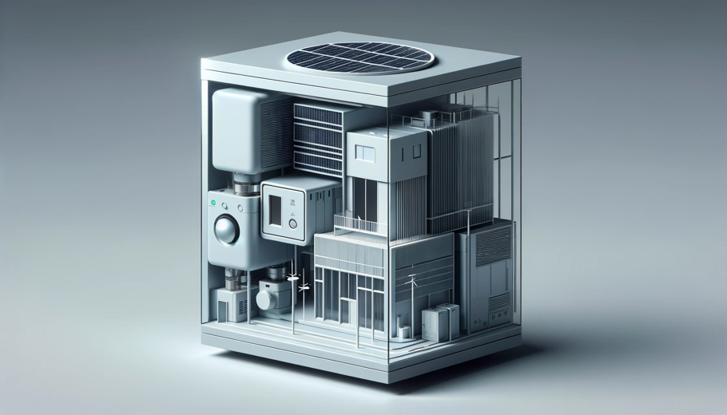

Here is a design concept for the energy harvesting device tailored to your specifications. It features a sleek, minimalist design suitable for a coastal urban environment in Australia. The device integrates the three key modules you described: an energy accumulation module, an energy storage module, and an energy utilization module. This design is aimed to be compact, modern, and efficient, while complying with Australian Standards for Electrical Equipment and fitting within the specified budget.

**User:**

Based on the design you gave me above, please explain each module specifically.

**GPT:**

Certainly, let's delve into the specifics of each module in the energy harvesting device design:

1. **Energy Accumulation Module:**
   * **Function:** This module is responsible for deriving energy from an external source. Given the coastal urban environment in Australia, this could involve harnessing solar power, wind energy, or even tidal energy. The key here is to utilize renewable resources that are abundant in such a setting.
   * **Design Aspects:** To keep in line with the minimalist design, the accumulation module would likely be sleek and integrate seamlessly with the device's overall structure. For example, solar panels could be thin and aesthetically integrated into the device's surface, while wind or tidal components would be designed to minimize visual impact.
   * **Material Considerations:** Durability is crucial, especially in a coastal environment where saltwater and wind can be corrosive. Materials like corrosion-resistant metals or advanced composites would be ideal.
2. **Energy Storage Module:**
   * **Function:** This module's primary role is to store the energy accumulated by the first module. This is essential for providing a continuous power supply, especially during periods when the external energy source is not available (like at night for solar power).
   * **Design Features:** The storage module needs to be compact yet efficient. Lithium-ion batteries or other advanced energy storage technologies could be used, offering high energy density and longevity.
   * **Maintenance and Accessibility:** The design would ensure that the batteries or storage units are easily accessible for maintenance or replacement, but secured enough to prevent tampering or damage.
3. **Energy Utilization Module:**
   * **Function:** This module is responsible for utilizing the stored energy to power other devices. This could include small electronic devices like sensors, heating/cooling systems, actuators, or other low-power devices commonly used in urban settings.
   * **Integration and Efficiency:** The module would be designed to efficiently convert and distribute the stored energy to the connected devices. It would include necessary electronic components like inverters, controllers, and power management systems.
   * **User Interface and Control:** It might also feature user-friendly interfaces for monitoring and controlling the output, possibly even allowing remote management via smart technology.

Each of these modules would be designed to meet the criteria of ease of installation, minimal maintenance, and adherence to Australian electrical standards, all within the budget of A$50,000. The overall design would be such that it not only fulfills functional requirements but also blends aesthetically into the urban landscape.